**Midterm Lab Task 2.   
Using Loops and Selection statements**

**Problem 1.**

Create a countdown timer, where the user is prompted to enter time in seconds and will countdown to zero (set timer delay to 1) using timer.sleep(time_lapse). The program should prompt the user to test the timer if the answer is ‘y’ it will ask the user to enter time in second. If the answer is ‘n’ it will terminate the timer. Your response to y or n should be case insensitive.

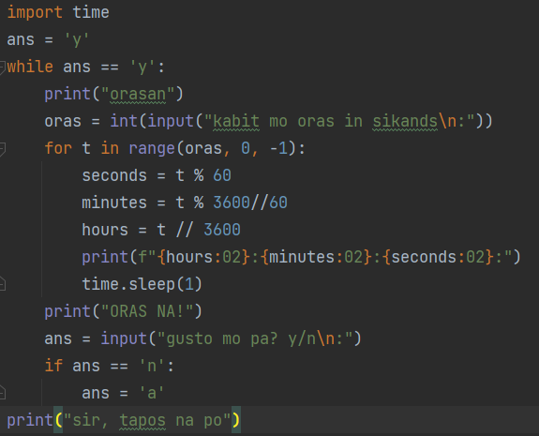

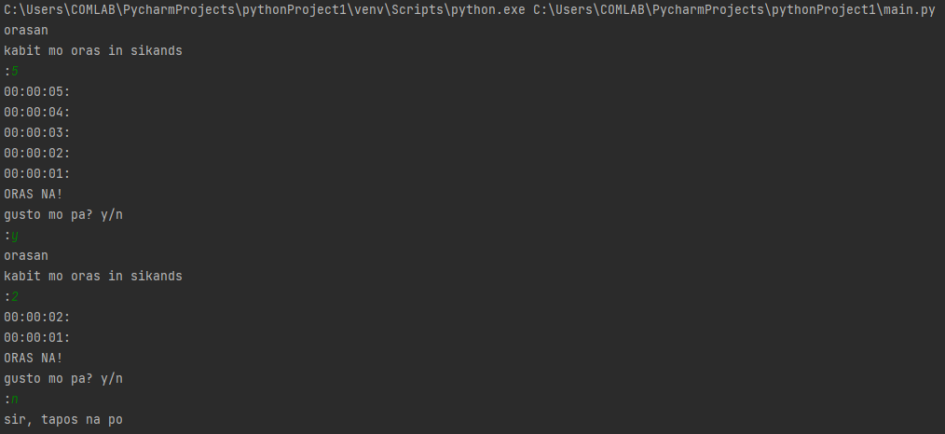

**Problem 2.**

